* Find publish data of webpage
  + Inurl:
  + &as_qdr=y15
* Runtime system (or runtime environment) implements parts of an execution model
  + What is an execution model?
    - A programming language consists of 2 things
      * Grammar/ syntax
      * An execution model
        + An execution model specifies the behavior of elements of the language
* FreeRTOS
  + <https://www.freertos.org/FAQWhat.html#WhyUseRTOS>
  + Explains why we want RTOS
* Side by side Comparison of RTOSs
  + <https://en.wikipedia.org/wiki/Comparison_of_real-time_operating_systems>
* What exactly is Node.js?
  + <https://www.freecodecamp.org/news/what-exactly-is-node-js-ae36e97449f5/>
  + Explains that
    - Node js is a runtime environment for Javascrpit
    - A {Progaming language X} runtime environment includes everything you need to run a program written in {Programming language X}
* Machine Vision Software: Real-time operating systems target machine vision applications
  + <https://www.vision-systems.com/boards-software/article/16738255/machine-vision-software-realtime-operating-systems-target-machine-vision-applications>
* What is an RTOS and what to expect of an RTOS that you want to use
  + <https://www.intervalzero.com/real-time-operating-system/>
* Gard real time systems
  + <https://www.electronicshub.org/real-time-operating-system-rtos/#Hard_Real_Time_Systems>
* A Comprehensive List of 3D Sensors Commonly Leveraged in ROS Development
  + <https://rosindustrial.org/3d-camera-survey>
  + Web Page published was published : july 10, 2019
    - <https://www.google.com/search?q=inurl%3Ahttps%3A%2F%2Frosindustrial.org%2F3d-camera-survey&oq=inurl%3A&aqs=chrome.0.69i59l2j69i57j69i58j69i61.4569j0j7&sourceid=chrome&ie=UTF-8&as_qdr=y15>
  + <https://www.geeksforgeeks.org/real-time-systems/>
  + <https://www.differencebetween.com/difference-between-hard-and-vs-soft-real-time-system/>
* Open source hard real time operating systems
  + <https://www.osrtos.com/>
    - MaRTE
      * <https://www.osrtos.com/rtos/marte/>
    - Xenomai
      * <https://www.osrtos.com/rtos/xenomai/>
* Java
  + There are extensions to Java that allow it to be a real time language
  + Yan vitech
    - Did work on how to convert java to a real time programming language
* **Might want to look at what other languages support real time?**
  + Go might be able to do it because it is statically compiled
  + <https://www.ubuntupit.com/top-15-best-embedded-systems-programming-languages/>
    - Python
    - Ada
    - Lua
    - Assembly
* Real time is about meeting deadlines and guaranteeing that deadlines are met by tasks
  + Deadlines are not met by sporadic tasks
  + **Want to look at real time scheduling tools**
    - [**http://beru.univ-brest.fr/~singhoff/cheddar/**](http://beru.univ-brest.fr/~singhoff/cheddar/)
    - **Ways to measure** 
      * **Measurement analysis** 
        + involves measuring execution times of short code segments on real hardware or on simulator for some set of inputs. Measurements are taken by using a processor clock or external hardware units such as the oscilloscope of a logic analyzer.
        + Cant sdo this because of covid
      * **Static analysis**
        + **Wikipedia page showing different kinds of tools for static code analysis**

<https://en.wikipedia.org/wiki/List_of_tools_for_static_code_analysis>

* + - * + What is static analysis

<https://www.absint.com/ait/am486.htm>

Static analysis WCET estimation was developed as an alternative to measurement-based estimation. The main advantage of static analysis is that it is not necessary to take measurements from a real target, minimizing cost and effort.

Static analysis estimation requires a precisely accurate model of the timing characteristics of the processor, which includes the behavior of pipelines, caches, memory, buses, and any other feature of the hardware under examination that may affect execution time of machine instructions. This is done without executing the code.

two key weaknesses:

It is pessimistic as it identifies the pathological – worst theoretically possible - WCET.

Complex architectures, such as multicore processors, cannot be accurately modelled.

* The key thing in real time systems os to predict WCET
  + Need to know what worst case is
  + There is static and dynamic analysis to look at
    - <https://www.rapitasystems.com/worst-case-execution-time>
      * Measure metn analysis
* **DEFINITION: Worst Case execution time**
  + <https://www.rapitasystems.com/worst-case-execution-time>
  + Task
    - Definition of task: Piece of code that will be run on a single thread
      * A task issues a sequence of jobs to the processor which are queued and executed
  + Execution time
    - Definition applied to job level granularity
  + WCET
    - High level system requirements will specify maximum response times for a task, known as a deadline.
* Cameras
  + Intel realsense
    - estimate visual latency with computer vision (but it is not proper latency testing)
      * [https://dev.intelrealsense.com](https://dev.intelrealsense.com/docs/rs-latency-tool)
      * IS THERE ANYHTING WE CAN DO HERE???
    - <https://store.intelrealsense.com/buy-intel-realsense-depth-camera-d435i.html>
    - <https://store.intelrealsense.com/buy-intel-realsense-tracking-camera-t265.html>
* Open-source SLAM with Intel RealSense depth cameras
  + Depth cameras - Extracts 3D information from a scene
    - <https://github.com/IntelRealSense/realsense-ros/wiki/SLAM-with-D435i>
  + Tracking Camera - Find your place in the world.
    - <https://www.youtube.com/watch?v=tcJHnHpwCXk>
  + Visual Odomoetry Algortihms
    - Google Cartographer
    - GMapping
    - Hector SLAM
    - **RTabMAP**
      * 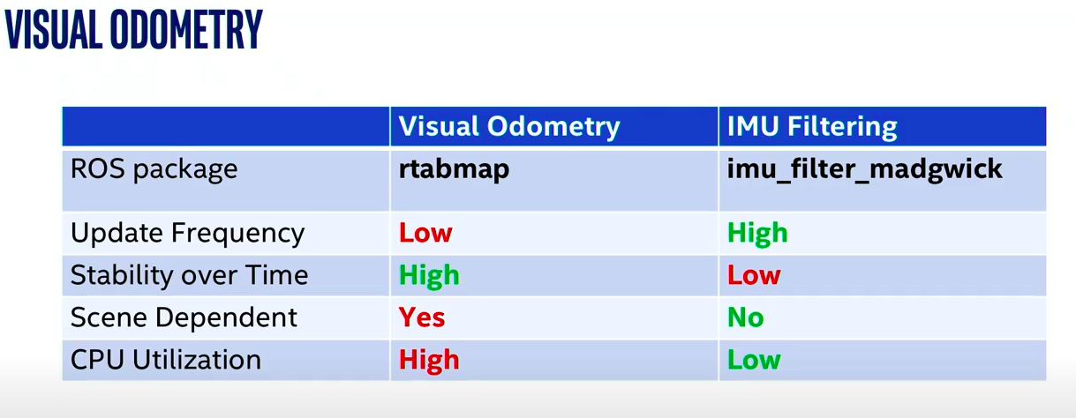
      * 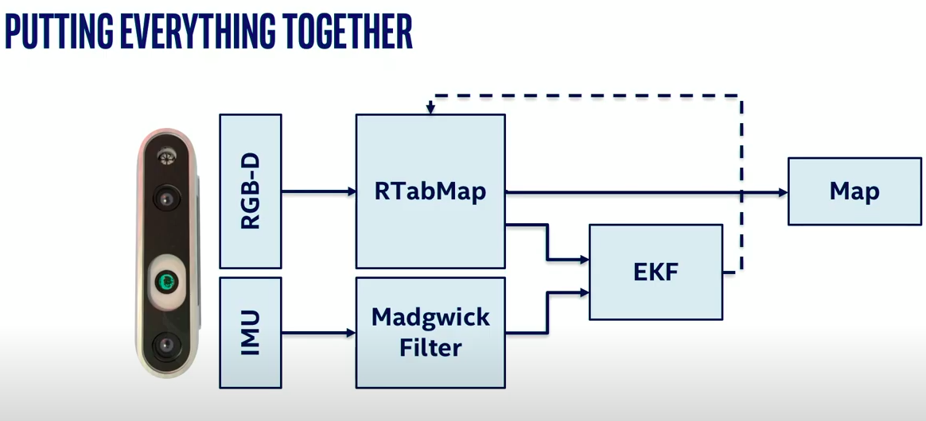
      * <https://github.com/IntelRealSense/realsense-ros/wiki/SLAM-with-D435i>
  + ORB SLAM
  + Rovio
* Other cameras that I looked at (most appealing at top)
  + Pulled from this list
    - <https://rosindustrial.org/3d-camera-survey>
  + <https://store.stereolabs.com/products/zed>
  + <https://www.amazon.com/Microsoft-Windows-Development-Requires-Dedicated/dp/B00KZIVEXO>
  + <https://www.ifm.com/us/en/product/O3X100>
  + <https://www.amazon.com/Asus-Xtion-PRO-LIVE-90IW0122-B01UA/dp/B00CET0ZBO>
* Surveyed different RGBD 3d cameras
  + Want to use intel realsense
    - Best for price
    - Though it does not report latency informaation
      * Maybe i can use this as motivatiosnto to WCET analysis
* Surveyed different real time operating operating systems and i a looks like there were only 2 major hard real time systems
  + Xenomai
    - Probably will use this one
  + MaRTE
* ROS2
  + Set of common libraries to use for robotic applications
  + <https://index.ros.org/doc/ros2/>
  + <https://github.com/ros2>
  + Includes real time support
    - ROS2 Design: Introduction to Real-time Systems
      * <https://design.ros2.org/articles/realtime_background.html>
        + Best Practices in Real-time Computing

In general, an operating system can guarantee that the tasks it handles for the developer, such as thread scheduling, are deterministic, but the OS may not guarantee that the developer’s code will run in real-time. Therefore, it is up to the developer to know what the deterministic guarantees of an existing system are, and what she must do to write hard real-time code on top of the OS.

* + - <https://github.com/ros2/realtime_support>
    - <https://github.com/ros2/cartographer>
* Open CV
  + Optical Flow
  + <https://opencv-python-tutroals.readthedocs.io/en/latest/py_tutorials/py_video/py_lucas_kanade/py_lucas_kanade.html>